VISVESVARAYA TECHNOLOGICAL UNIVERSITY
Jnana Sangama, Santhibastawad Road, Machhe

Belagavi - 590018, Karnataka, India


A SURVEY REPORT

ON

“Software Tool: IntelliJ Idea”

BACHELOR OF ENGINEERING
IN

INFORMATION SCIENCE AND ENGINEERING

For the Academic Year 2019-2020
Submitted by

Student Name: Pavan Kumar. P USN: 1JS18IS064

Under the Guidance of

Fathima Afroz

Assistant Professor, Dept. of ISE, JSSATE



2019-2020

DEPARTMENT OF INFORMATION SCIENCE AND ENGINEERING

JSS ACADEMY OF TECHNICAL EDUCATION

JSS Campus, Dr. Vishnuvardhan Road, Bengaluru-560060

JSS MAHAVIDYAPEETHA, MYSURU

JSS ACADEMY OF TECHNICAL EDUCATION
JSS Campus, Dr. Vishnuvardhan Road, Bengaluru-560060

DEPARTMENT OF INFORMATION SCIENCE & ENGINEERING


CERTIFICATE

This is to certify that Survey work entitled “Software Tool: IntelliJ Idea” is a bonafide work carried out by Pavan Kumar. P [1JS18IS064] in partial fulfilment for the award of degree of Bachelor of Engineering in Information Science and Engineering of Visvesvaraya Technological University Belagavi during the year 2019-2020.

Signature of the Guide |  | Signature of the HOD
Mrs. Fathima Afroz |  | Dr. Dayananda P
Assistant Professor |  | Professor & Head
Dept. of ISE |  | Dept. of ISE
JSSATE, Bengaluru |  | JSSATE, Bengaluru

ACKNOWLEDGEMENT

The satisfaction and euphoria that accompany the successful completion of any task would be incomplete without the mention of the people who made it possible. So with gratitude, we acknowledge all those whose guidance and encouragement crowned my effort with success.

We express our sincere gratitude for our beloved Head of the department, Dr. Dayananda P, for his co-operation and encouragement at all the moments of our approach.

It is our pleasant duty to place on record our deepest sense of gratitude to our respected guide Mrs. Fathima Afroz, Assistant Professor, for the constant encouragement, valuable help and assistance in every possible way.

Pavan Kumar. P [1JS18IS064]

INDEX

- Aim

- Introduction

- Design of IntelliJ

- Architecture of IntelliJ

- Working

- Features

- Advantages of IntelliJ

- System requirements to install IntelliJ

- Review of IntelliJ

- Start-up Performance

- Indexing Speed and Full specs of the computers

- Conclusion

- References
SOFTWARE TOOL: IntelliJ Idea 

Aim:

This Software Tool is created to analyse the codes written by us, for looking connections between symbols across all project files and languages. It provides deep insight to our code. Using this also provides in-depth coding assistance, quick navigation, clever error analysis and refactorings. IntelliJ IDEA was one of the first Java IDEs to cross the Refactoring Rubicon by implementing the Extract Method refactoring for Java. It also describes some of the problems we’re facing when implementing refactorings and possible directions for future development.

Introduction:
IntelliJ Idea is one of the most powerful and popular Integrated Development Environments (IDE) for Java. It is developed and maintained by JetBrains and available as community and ultimate edition. This feature rich IDE enables rapid development and helps in improving code quality. IntelliJ IDEA, JetBrains’ flagship Java IDE, provides high-class support and productivity boosts for enterprise, mobile and web development in Java, Scala and Groovy, with all the latest technologies and frameworks supported out of the box.

Definition of IDE:
IDE stands for Integrated Development Environment. It is a combination of multiple tools, which make software development process easier, robust and less error-prone. It has following benefits over plain text editor −
- Integration with useful tools like compiler, debugger, version control system, build tools, various frameworks, application profilers and so on.
- Supports code navigation, code completion, code refactoring and code generation features which boosts development process.
- Supports unit testing, integration testing and code coverage via plug-ins.
- Provides rich set of plug-ins to enhance IDE functionality further.

The first version of IntelliJ IDEA was released in January 2001, and was one of the first available Java IDEs with advanced code navigation and code refactoring capabilities integrated.
In a 2010 InfoWorld report, IntelliJ received the highest test centre score out of the four top Java programming tools: Eclipse, IntelliJ IDEA, NetBeans and JDeveloper.^{[8]}
In December 2014, Google announced version 1.0 of Android Studio, an open-source IDE for Android apps, based on the open source community edition of IntelliJ IDEA. Other development environments based on IntelliJ's frameworkinclude AppCode, CLion, DataGrip, GoLand, PhpStorm, PyCharm, Rider, RubyMine, WebStorm, and MPS.

Design of IntelliJ:
IntelliJ IDEA is designed using GUI Designer.
GUI Designer enables to create graphical user interfaces (GUI) for our applications using Swing library components. The tool helps you speed up the most frequent tasks: creating dialogs and groups of controls to be used in a top-level container such as a JFrame. When you design a form with the GUI Designer, you create a pane rather than a frame. Dialogs and groups of controls created with the GUI Designer can coexist in the application with the components that you create directly with Java code. Using the GUI Designer is subject to the following limitations:
- GUI Designer does not support modelling of non-Swing components.
- The GUI Designer does not create a main frame for an application, nor does it create
menus.
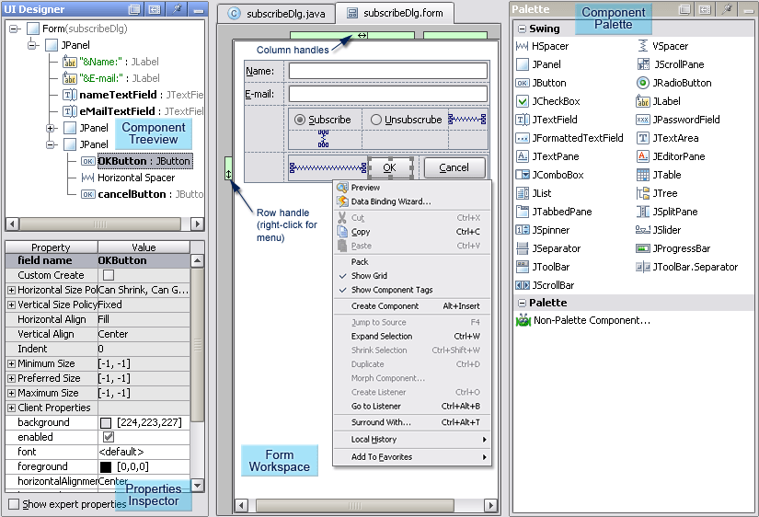
Fig: Components of GUI
IntelliJ IDEA is designed around the coding principle that developers should be allowed to write codes with as less distraction as possible. That is why in this case, the editor is the only thing visible on the screen, with dedicated shortcuts for all other coding-unrelated functions.
- Editor-centric environment − Quick pop-ups help in checking additional information without leaving the current context.
- Shortcuts for everything −IntelliJ IDEA has keyboard shortcuts for nearly everything, including rapid selection and switching between tool windows and many more.
- Inline debugger −Inline debugger allows you to debug application in IDE itself. It makes the development and debugging process seamless.

Java development tools in the industry, especially in intelligent code assistants, code prompts, refactoring, J2EE support, various version tools, JUnit, CVS integration, code analysis, innovative GUI design, etc. The function can be said to be extraordinary. RebelLabs conducted a survey of Java tools and technologies for 2016, with 46% of developers using IntelliJ IDEA, which has exceeded 41% of Eclipse
- Virtual File System: The Virtual File System is a component ofthe IntelliJ platform that encapsulates most of the activities used to process files. Its main uses include:
- Program Structure Interface. The program structure interface is a layer in the IntelliJ platform that is responsible for parsing files and creating syntax and semantic code models that support so many platform features.
- Component Persistence. Component Persistence is an API provided by the IntelliJ platform that allows components or services to restart their state between persistent IDEs. You can use a simple API to save some values, or use the Persistent State Component interface to save the state of more complex components.
Every aspect of IntelliJ IDEA is specifically designed to maximize developer productivity. Together, powerful static code analysis and ergonomic design make development a productive and enjoyable experience

Architecture of IntelliJ:
To help the developers organize their workflow, IntelliJ IDEA offers them an amazing toolset, which comprises of a decompiler, Docker support, bytecode viewer, FTP and many other tools −
- Version control − IntelliJ supports most of the popular version control system like Git, Subversion, Mercurial, CVS, Perforce, and TFS.
- Build tools − IntelliJ supports Java and other build tools like Maven, Gradle, Ant, Gant, SBT, NPM, Webpack, Grunt, and Gulp.
- Test runner and code coverage − IntelliJ IDEA lets you perform unit testing with ease. The IDE includes test runners and coverage tools for major test frameworks, including JUnit, TestNG, Spock, Cucumber, Scala Test, spec2, and Karma.
- Decompiler − IntelliJ comes with a built-in decompiler for Java classes. When you want to take a look inside a library that you do not have the source code for, you can do it without using any third-party plug-ins.
- Terminal − IntelliJ provides built-in terminal. Depending on your platform, you can work with the command line prompt, like PowerShell or Bash.
- Database tools − IntelliJ provides database tools, which allow you to connect to live databases; run queries; browse and update data; and even manage your schemas in a visual interface from IDE itself.
- Application server − IntelliJ supports major application servers: Tomcat, JBoss, WebSphere, WebLogic, Glassfish, and many others. You can deploy your artifacts onto application servers and debug the deployed applications in IDE itself.
- Docker support − Via a separate plug-in, IntelliJ provides a dedicated tool window that lets you connect to locally running Docker machines.
- References and Find Usages: A key component of most refactorings is a procedure called Find Usages, which finds all references to a particular PSI element. Its key component is the word index – an inverted index recording the occurrences of each identifier in the source code. It is used to find the files which may contain references to the element. Then all references in each candidate file are resolved to check if they indeed resolve to the correct target. When a referenced element is affected by a refactoring (for example, rename or move), all references to it are notified. The reference can then update itself according to its language, context and so on.
IntelliJ IDEA, which started its life as a pure Java IDE, is now branching out to support multiple languages. At the moment the refactoring implementations (except for the most basic ones like
rename and move) are completely tied to a particular language. We would like to be able to extract the “essence” of the most important refactorings like Extract Method into shared code, separated from the language-specific parts.

Working:
Unlike NetBeans [2], IntelliJ IDEA doesn’t rely on an external compiler for parsing and analysing code. Instead, it uses custom developed lexers and parsers to convert the source code into a form of AST called a PSI tree (PSI stands for Program Source Interface). PSI supports both low-level tree traversal and higher-level semantic operations (e.g. getting a list of methods in a Java class). The general structure of the PSI remains valid even if the underlying code contains syntax errors. In places containing errors, special markers are inserted in the PSI tree, which are used for error highlighting. Those markers usually do not affect refactorings, so broken code can also be refactored. Relationships between different pieces of code (for example, method calls) are modelled by references. References can cross languages.

General Refactoring Workflow:
Most refactorings in IntelliJ IDEA follow the same general sequence of steps:
- Showing the UI for choosing refactoring options;
- Searching for usages of the element to be refactored;
- Checking for conflicts (for example, methods which will not be accessible from the new location of a moved method);
- Showing the list of usages that will be affected by the refactoring, and allowing to exclude some of them;
- Executing the refactoring;
- Reformatting affected fragments
Patterns: Another tool used while implementing refactorings, patterns are an embedded DSL used to match fragments of an AST tree using a concise notation.
Fig: Pattern Example
Control Flow: To implement refactorings like Extract Method, IntelliJ IDEA builds a control flow graph of the methods being processed. The graph is composed of abstract language-independent instructions (like “read”, “write”, “goto”, “conditional goto” etc.) linked by edges specifying possible variants of control flow.
Fig: Control Flow Example
Bayou’s BSL synthesizer: Implementation of Bayou’s BSL synthesizer is a ready-to-use web service for code synthesis, but it cannot be integrated into IntelliJ IDEA as a plugin without significant rework. IntelliJ IDEA does not require installation of a JAVA interpreter, so most users might not have it installed. All layers implemented in JAVA must be re-implemented on the JVM platform. Moreover, current Bayou architecture does not support configuration of metamodels, each metamodel is implemented as a separate application.
A BSL synthesizer needs models to perform. Unfortunately, these files are quite large (~100
Mb for the Android SDK model and ~200 Mb for the Java STDlib model), so we can’t distribute them with the plugin directly. Currently, these models are stored in an Amazon S35 repository along with a descriptor file listing all supported models, paths to corresponding files and MD5 hashes of these files. Each instance of the plugin creates a directory for local repository. If the requested model is missing on disk or corrupted it will be downloaded from the remote repository.
Fig: Data-based code synthesis in IntelliJ IDEA

- Input Layer: The purpose of Input Layer is to handle input data (some code with evidence): extract evidence from the code and create code’s intermediate representation for Concretization Layer. This intermediate representation will be used as context for synthesized code. There is no such layer in the abstract BSL synthesizer, its role here is strictly technical. Having input data processed in a separate layer, we can pass evidence into the synthesizer in different ways: embed it into code, or pass along with code and a position to insert synthesized code into.
- Embedding Layer: Embedding Layer handles embedding the evidence received from Input Layer. Embedding Layer supports several algorithms required by different metamodels: TF-IDF and LDA for Android SDK and k-hot encoding for Java STDlib. This layer corresponds to Evidence Embedding Layer in the abstract BSL synthesizer’s architecture. It is parameterized by evidence types accepted by the metamodel and embedding algorithms for each evidence type. In case embedding requires some additional data (an LDA model, a k-hot encoding dictionary, etc.) they are also added to layer’s configuration.
- AST Synthesis Layer: AST Synthesis Layer performs synthesis of sketches’ ASTs by the embedded evidence. This layer can be parameterized with a number of hidden layers of encoder and decoder; however, this is not used currently for existing metamodels. This layer corresponds to both Evidence Encoder Layer and Intent Decoder Layer. Within the AST Synthesis Layer evidence is encoded into an intent latent variable element and then decoded from this element into a sketch. Two layers are combined into one because the change of parameters or models of one layer is impossible without corresponding changes to the other layer. AST Synthesis Layer is parameterized by the BED model.
- Quality Measurement Layer: Quality Measurement Layer measures quality of synthesized sketches, deduplicates and ranks them. There is also no such layer in the abstract BSL synthesizer, here it is used to isolate quality measuring algorithms into individual abstractions. Thus, we can use different ranking algorithms for different metamodels, or even let our users choose which quality metrics to use.
- Concretization Layer: Concretization Layer turns sketches obtained from Quality Measurement Layer and code’s intermediate representation received from Input Layer into Java code. This layer corresponds to Combinatorial Concretization Layer in the abstract BSL synthesizer’s architecture. Concretization algorithm has several parameters (for example, recursive search depth while synthesizing method arguments), however all existing metamodels use default settings

When a refactoring need to generate some code (for example, when Extract Method generates the stub for the extracted method), the code is usually built from text (rather than from individual AST nodes) and then updated as necessary for a specific operation. The formatter is automatically called after every batch of modifications. It reformats the affected range to fix the indentation and line breaks, replaces fully-qualified names with imports, and so on. The IDE provides integration with build or packing tools like grunt, bower, gradle and SBT. It supports version control systems like Git, Mercurial, Perforce, and SVN. Databases like Microsoft SQL Server, Oracle, PostgreSQL, SQL lite and MySQL can be accessed directly from the IDE in the Ultimate edition, through an embedded version of Data Grip.

Features:
IntelliJ IDEA has some top productive Java code completion features. Its predictive algorithm can accurately assume what a coder is attempting to type, and completes it for him, even if he doesn’t know the exact name of a particular class, member or any other resource.
Some of the great features of IntelliJ IDEA are:
- Smart Code Completion.
- On-The-Fly Code Analysis.
- Advanced Refactoring.
- Detecting Duplicates.
- Inspection and Quick Fixes.
- Shortcuts for Everything.
- Terminal.
- Navigation and Search.
- Structural Search ……………etc.
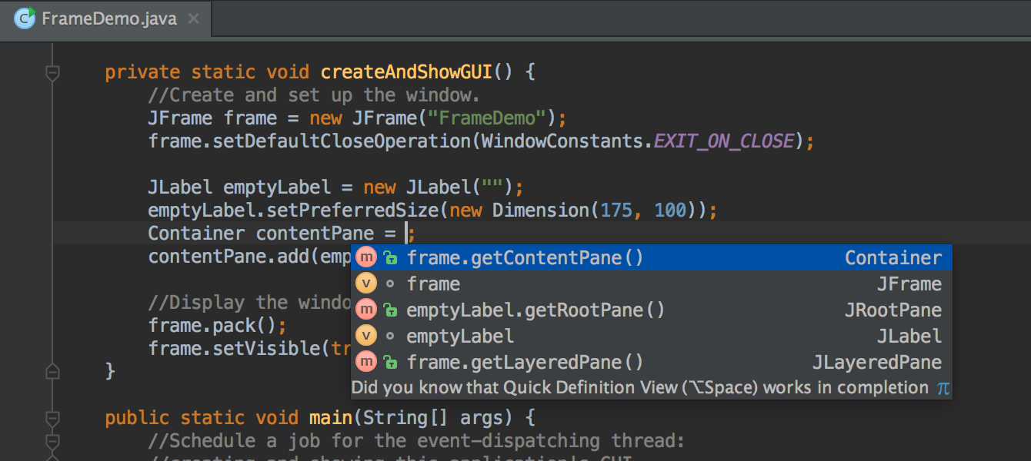
Fig: Features of IntelliJ Idea

- Ex: Smart Code Completion: This command filters the list of types, methods, and variables to match the expected type of an expression. It works anywhere as long as ReSharper can determine the expected type of the expression, for example, right-hand sides of assignments, variable initializers, or return statements. If several return types are possible, ReSharper detects the most recently used symbol of an applicable type and automatically selects it in the lookup list. Smart Completion can also suggest creating anonymous delegates, lambda expressions, and regular methods, as well as local variables for out parameters. In addition to that, in object initializers, Smart Completion suggests fields/properties that were not yet assigned a value.
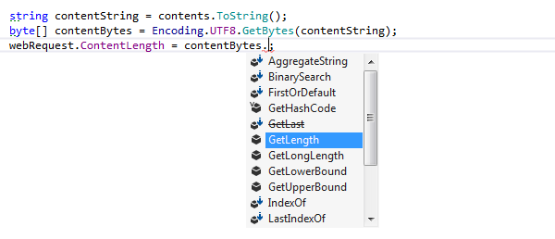
Fig: Smart Code Completion

- Ex: Inspections and Quickfixes: In addition to “big name” refactoring operations like Extract Method or Rename, which are explicitly invoked by the user, IntelliJ IDEA provides a large number of context-sensitive “quickfixes” which are automatically suggested when the static code analysis detects a certain “code smell” or potential improvement. The quickfixes usually have simpler UI and perform more targeted operations, but many of them can also be considered refactorings.
Fig: Rule Inspection in the If Block
Fig: Quickfix in the If Block

- Ex: Structural Search: This feature provides a “Query by Example” interface for navigating and modifying Java and XML/HTML code, somewhat similar to Project Jackpot [3]. It allows the user to enter a code fragment containing some variables, to specify the constraints for those variables, and optionally to enter a replacement pattern specifying how the occurrences should be changed. This provides a way for the user to perform arbitrary custom refactoring operations. Structural Search also can be used as an API for implementing other refactorings.

Fig: Structural Search Template

Advantages of IntelliJ:
Since 2012, IntelliJ IDEA has been rapidly rising. In 2016, it captured 46% of the market share of the developer market. According to a research in 2018, the market share of IntelliJ IDEA increased to 55.4％, winning the throne of the Java IDE world. Martin Fowler, renowned author, software consultant and speaker, speaks highly of IntelliJ IDEA on his blog. IntelliJ IDEA also achieved 98% customer satisfaction, which is extremely high. From the design of IntelliJ IDEA, we can see:
- It Does Not Break Developers Out of Flow. Every aspect of IntelliJ IDEA is designed with ergonomics in mind. IntelliJ IDEA is built around the idea that every minute a developer spends in the flow is a good minute, and things that break developers out of flow are bad things. Every design and implementation decision considers the possibility of interrupting developer's flow and seeks to eliminate or minimize it.
- IntelliJ IDEA claims that they use ergonomics in the design of the IDEA: "The capable and ergonomic IDE for JVM". Ergonomics is a science that focuses on the study of how to enhance human comfort, and reduce fatigue and discomforts through product design. This concept is very important in-home design and human engineering to help you feel more comfortable, increase the efficiency, and reduce the pressure.
JetBrains IDEs are built on top of a single IntelliJ Platform developed by JetBrains. This shared platform helps ease the learning curve by providing a familiar development environment across tools, languages and platforms.

System requirements to install IntelliJ:
IntelliJ Idea can be installed in different Operating Systems such as Windows, Linux, MacOS. Here are the System Requirements and Specifications that are required for installing JetBrains’s IntelliJ Idea:

- On Windows:
IntelliJ is compatible with almost all versions of Windows prior to 2003. A comprehensive list will be: Windows 10/8/7/Vista/2003/XP. It is recommended that you shut down all other applications before you install IntelliJ on Windows.

System Requirements:
- A minimum 2 GB of RAM capacity is recommended for seamless performance.
- For better visualization, 1024x768 screen resolution is recommended.
- Minimum 300 MB disk space for installation and additional 1 GB for cache.
- On Linux
For installation of IntelliJ on Linux platforms, you need to note that a 32-bit JDK is not bundled, so a 64-bit system is recommended.

System Requirements:
- GNOME, KDE or XFCE desktop environment
- Minimum 2 GB of RAM is recommended for seamless usage
- 300 MB of disk space for installation and addition 1 GB for caches
- For better visualization, 1024x768 screen resolution is recommended.
- On MacOS
For installing IntelliJ idea on MacOS u need minimum of 2GB ram and disk space of 2.5GB.
System Requirements:
- 300 MB of disk space for installation and addition 1 GB for caches
- For better visualization, 1024x768 screen resolution is recommended

 | Windows | macOS | Linux
OS Version | Microsoft Windows 8 or later | macOS 10.13 or later | Any Linux distribution that supports Gnome, KDE, or Unity DE
RAM | 2 GB RAM minimum, 8 GB RAM recommended
Disk space | 2.5 GB and another 1 GB for caches minimum, SSD drive with at least 5 GB of free space recommended
JDK Version | Add support for Java 14^{[11]}
JRE Version | JRE 11 is bundled.^{[12]}
Screen resolution | 1024×768 minimum screen resolution. 1920×1080 is a recommended screen resolution.

Review of IntelliJ:
Out of all three major IDEs of Java i.e.: Eclipse, NetBeans, IntelliJ Idea. Idea wins hands down on almost all fronts. Here are some pros and cons of Idea:
Pros
- Most Importantly, this IDE is Lightning Quick; no other IDE is even close in speed and performance.
- Very feature rich; definitely a match for Eclipse, at least when developing in Java.
- Built in keyboard shortcuts for virtually everything; you can also create your own.
- Smart code completion is second to none.
- File navigation is a breeze - put in any part of the name, and you get a list of possible matches. No need ever to search through folders manually.
- Has a built-in command prompt terminal.
- Has a built in RDBMS management tool.
- Has built in Maven command prompt + options.
- Configuration possibilities are virtually endless; artifact options, compile options, run configurations, servers etc.
- The list goes on…
Cons
- Because it is a commercial product, the community is much smaller, making it a little harder to find help, although the support service is quite good.
- The learning curve is a little steep, especially coming from NetBeans.
- The UI is not as simple and straightforward as NetBeans, although it is definitely way better than Eclipse’s.
- I miss Eclipse’s ability to link to external files; with IDEA, I have to relink every time I redeploy my JSP ‘s. Extremely annoying.
- The SVN control is not quite as nice as Eclipse’s SVN plugins, pity.
- It is very costly, although definitely worth it.

IntelliJ Idea is just an IDE. period. Eclipse is much beyond just an IDE - a platform and an ecosystem for building applications. The fact that eclipse is not managed by a single commercial entity but by a non-profit foundation where almost all major corporations participate actively. The plugins in Eclipse are not developed and managed by any single parent company but by organizations who specialize in their respective technologies.
IDEA was ground breaking in applying abstract code manipulation to the IDE space. IDEA applies the concept of manipulating code as a structure, not just string-munging and glorified search & replace. IntelliJ is a better product, but you pay for it. Eclipse is perfectly acceptable and usable product, and is free. Many of the advantages/drawbacks people cite are down to a lack of familiarity. This thread itself contains some anti-Eclipse comments which are simply inaccurate. Other things can be overcome by investing time on advanced setup — for example, Eclipse’s fast incremental compiler is much better, especially when debugging, but you can setup IntelliJ to use it.
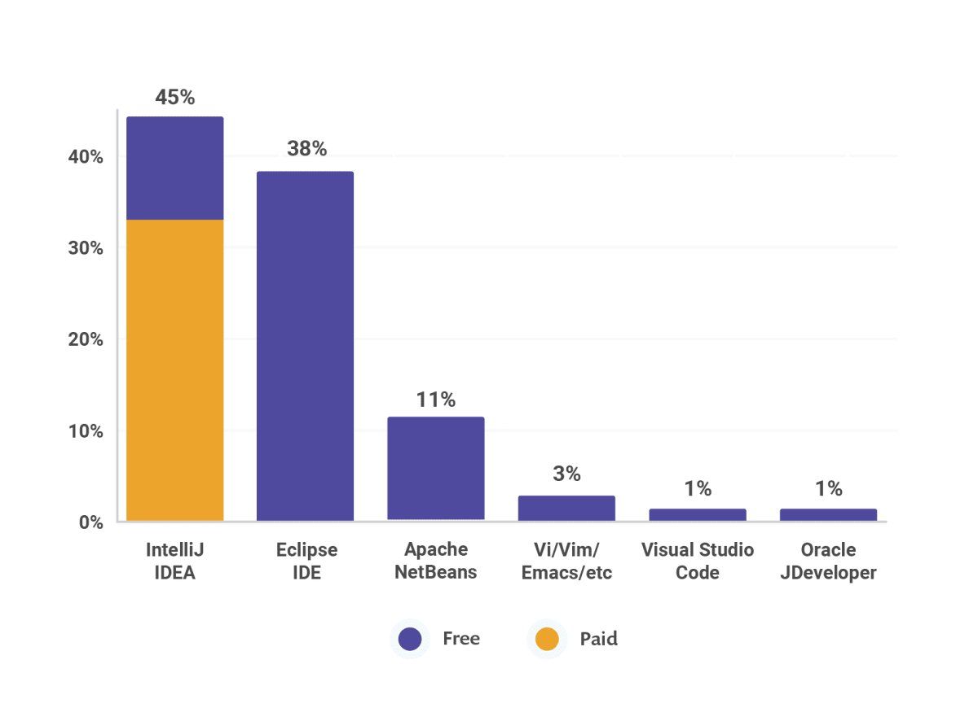
Fig: IntelliJ Idea vs Others

Start-up Performance:
As soon as we launch the IDE, we’ll see one of its major performance improvements much faster start-up. While we always strive to improve the IDE’s performance, since v2019.2 we have making special efforts to reduce start up times and this release cycle continues this long-term effort of speeding up the start-up time. This upcoming major version v2019.3 reduces start-up times even further by introducing substantial architectural changes to the IntelliJ Platform.
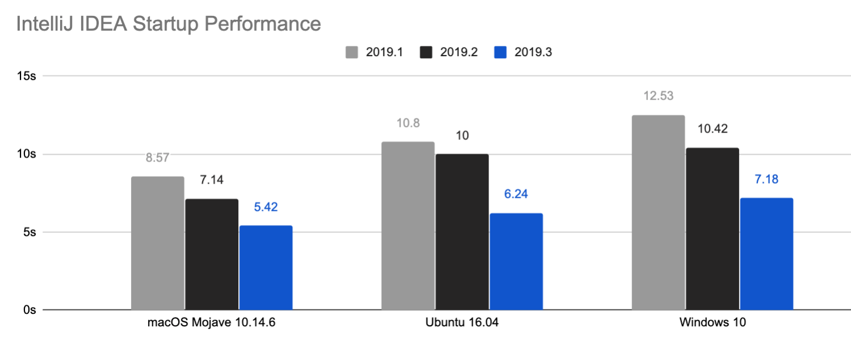
Fig: IDEA Start up performance

The first three phases – bootstrap, app initialization preparation, and app initialization – have been optimized significantly. The rest are not yet fully optimized, but they have been improved thanks to some platform-wide changes.
During the bootstrap and app initialization preparation phases, classes are loaded, the UI subsystem is initialized, and other low-level things happen. In an ideal world, the app initialization phase (including app component creation) should not even exist as everything should be queried on demand. But in real life, there are some heavy services – file indices, virtual file system, code styles, and so on. So now, instead of waiting sequentially for each one to load, the IntelliJ Platform provides service preloading with several policies (fully async or partially async). Some core services have already been updated to utilize this feature.
Indexing Speed and Full specs of the computers:
1. Sony Vaio Z, Core i5 (2.4 GHz), SSD, Windows 7 x64
2. Core i7 (2.8 GHz), HDD 10K rpm, Windows 7 x64
3. Core i7 (2.8 GHz), HDD 10K rpm, Ubuntu 10.10 x64
4. MacBook Air Core 2 Duo (2.13 GHz), SSD, Mac OS X 10.6.5
5. Dell Vostro Core 2 Duo (2.2 GHz), HDD 7200 rpm, Windows Vista
Indexing in IntelliJ IDEA is responsible for the core features of the IDE: code completion, inspections, finding usages, navigation, syntax highlighting, and refactorings. It starts when you open your project, switch between branches, after you load or unload plugins, and after large external file updates. For example, this can happen if multiple files in your project are created or generated after you build your project. Indexing examines the code of your project to create a virtual map of classes, methods, objects, and other code elements that make up your application. This is necessary to provide the coding assistance functionality, search, and navigation instantaneously. After indexing, the IDE is aware of your code. That is why, actions like finding usages or smart completion are performed immediately.
While indexing is in progress, the abovementioned coding assistance features are unavailable or partially available. Nevertheless, you can still work with the IDE: you can type code, work with VCS features, configure settings, and perform other code unrelated actions.

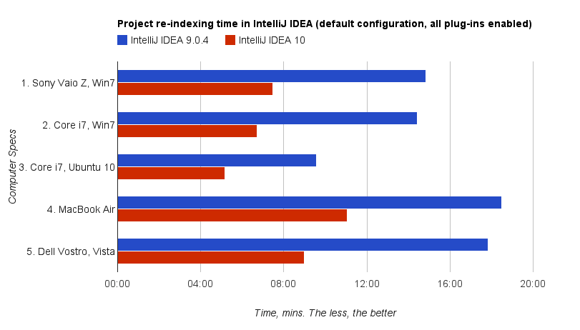
Fig: Indexing Speed of IDEA version 9.0.4 and 10
Conclusion:
All the variety of features and applications supported by IntelliJ IDEA is not powered by a single uniform engine, but rather by a large quantity of hand-written Java code, which is constantly being updated to support newly discovered special cases. Most of these complexities are caused by non-uniform semantics of the Java language. After IntelliJ IDEA has indexed your source code, it offers a blazingly fast and intelligent coding experience by giving relevant suggestions in every context: instant and clever code completion, on-the-fly code analysis and reliable refactoring tools. IntelliJ IDEA has a number of automatic refactorings available, all of which aim to let you, the developer, reshape your code in as low-impact way as possible. The aim is to make small, incremental changes, all the time keeping the code in a state that compiles.
References:
- JetBrains Programming System
http://www.jetbrains.com/mps/
- Tutorials point
https://www.tutorialspoint.com/intellij_idea/intellij_idea_useful_resources.htm
- Wikipedia
https://en.wikipedia.org/wiki/IntelliJ_IDEA
- Quora
https://www.quora.com/
- Jan Becicka, Petr Zajac, Petr Hrebejk Using Java 6 Compiler as a Refactoring and an Analysis Engine, ECOOP 2007
- Report on Data-based code synthesis in IntelliJ IDEA By Vladislav Tankov, Saint-Petersburg State University JetBrains.

